Revision History
Date | Version | Description | Author
<10/11/2015> | <0.1> | <Started to parts 1,2,4> | <Alhussam Alwani>  <Aras Selvi>

TABLE OF CONTENTS
1 Introduction 3
1.1 References 3
1.1.1 Project References 3
2 Software Architecture overview 3
3 Software design description 3
3.1 Component 1 3
3.1.1 Component interfaces 3
3.1.2 Component design description 3
3.1.3 Workflows and algorithms 3
3.1.4 Software requirements mapping 3
3.2 Component 2 3
3.2.1 Component interfaces 3
3.2.2 Component design description 4
3.2.3 Workflows and algorithms 4
3.2.4 Software requirements mapping 4
3.3 Component 3 4
3.3.1 Component interfaces 4
3.3.2 Component design description 4
3.3.3 Workflows and algorithms 4
3.3.4 Software requirements mapping 4
4 COTS Identification 4

Introduction
This software provides the basic functionalities of a school’s library. The software is divided into basic components.
This document describes the design of the LBDMS software system with the detailed design of those basic components.

References

Project References

# | Document Identifier | Document Title
01 | SDP | Software Development Plan
02 | SRS | Software Requirements Specifications
03 | STP | Software Test Plan

Software Architecture overview
//Student and Admin extends User class.
SignUp, LogInAdmin and LogInStudent extends Home Page
LogInAdmin includes Display, Search, Add/Delete, ViewUsers, Approve/Disapprove, Delete User
LogInStudent includes Display, Search, Borrow

Here you can see UseCase, Activiy and Package diagrams that are already given in SRS.
And a class diagram is provided.
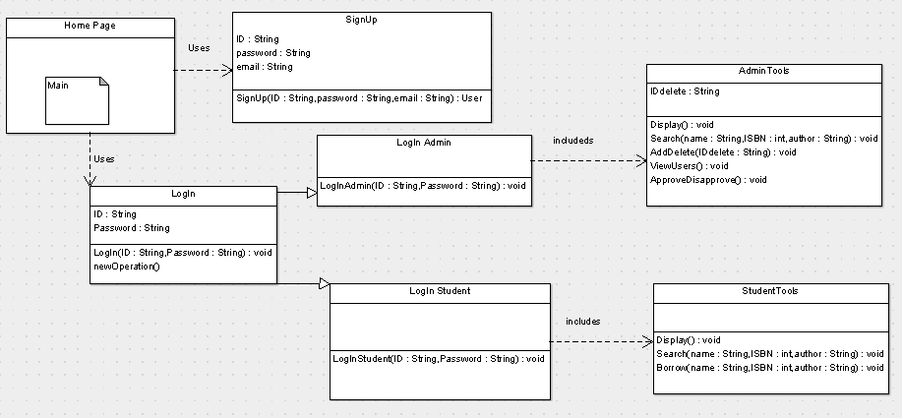

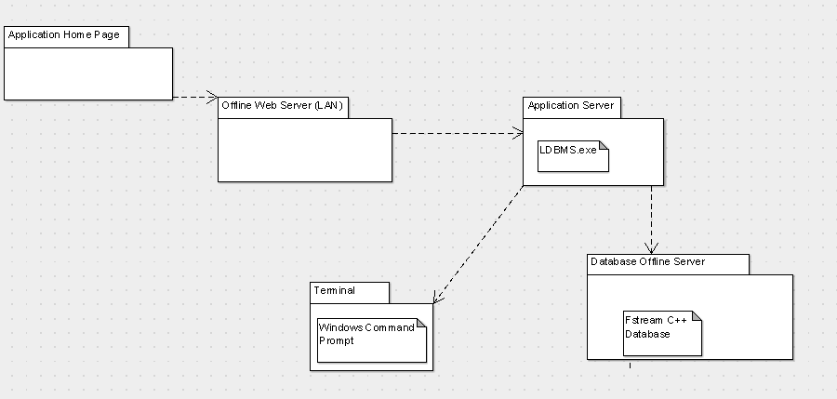

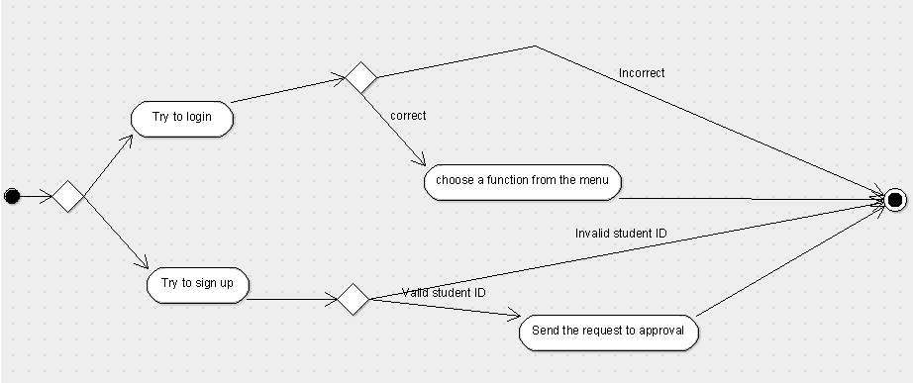

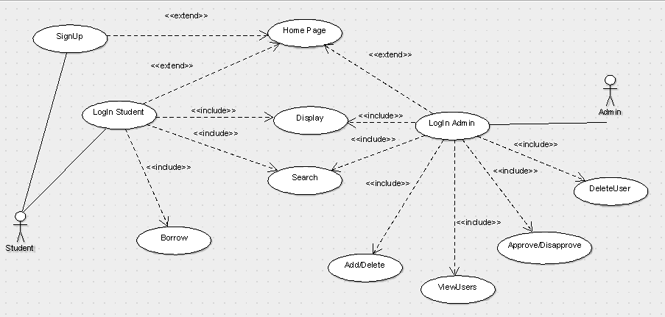

Software design description
Describe each top level package/component of your software and if necessary sub-components/sub packages.

Use Class diagrams, sequence diagrams and deployment diagrams to illustrate your description.

Component 1

Component interfaces
Describe the interfaces of the component and input output data

Component design description
Describe the design of the component, Use class diagrams to show the links between sub-components/sub-packages and or classes inside the component.

Workflows and algorithms
Use sequence diagrams and activity diagrams to show the workflows of components/packages/classes inside the component.
Describe algorithms, if possible. An algorithm may be described outside this document, in this case, add the reference to that document.

Software requirements mapping
List the SRS requirements handled by this component

Component 2
Repeat the pattern for each component.

Component interfaces
Describe the interfaces of the component and input output data

Component design description
Describe the design of the component, Use class diagrams to show the links between sub-components/sub-packages and or classes inside the component.

Workflows and algorithms
Use sequence diagrams to show the workflows of components/packages/classes inside the component.
Describe algorithms, if possible. An algorithm may be described outside this document, in this case, add the reference to that document.

Software requirements mapping
List the SRS requirements handled by this component

Component 3
Repeat the pattern for each component.

Component interfaces
Describe the interfaces of the component and input output data

Component design description
Describe the design of the component, Use package diagrams and/or class diagrams to show the links between sub-components/sub-packages and or classes inside the component.

Workflows and algorithms
Use sequence diagrams to show the workflows of components/packages/classes inside the component.
Describe algorithms, if possible. An algorithm may be described outside this document, in this case, add the reference to that document.

Software requirements mapping
List the SRS requirements handled by this component

COTS Identification
COTS (commercial of the shelf) libraries used in LDBMS are the following:
- Standard C++ input and output library (Iostream)
- Standard C++ file stream library (Fstream)

